RAMACHANDRA COLLEGE OF ENGINEERING (A) – ELURU

B.Tech V Semester Regular Examinations – December 2025

Course: Microprocessors and Microcontrollers (CSE–IoT) Course Code: 23C05102

---------------------------------------------------------------------------------------------------------------------------------------

PART-A

1. a)List the general-purpose registers of 8086 and their functions
- AX (Accumulator): Used for arithmetic, logical operations, and I/O.
- BX (Base Register): Used for indexed addressing.
- CX (Count Register): Holds loop/shift counters.
- DX (Data Register): Used in multiplication, division, and I/O operations.

b). What is the role of control signals in 8086?
Control signals manage and coordinate read/write operations, control memory and I/O access, regulate bus usage, and ensure proper timing and synchronization of data transfer.

c). What is the role of the stack in 8086 programming?
The stack temporarily stores data, return addresses, parameters, and supports subroutine calls and interrupt handling.
d). What is the function of PUSH and POP instructions?
- PUSH: Places (stores) a word onto the stack and decrements SP.
- POP: Removes (retrieves) a word from the stack and increments SP.

e). Define DMA and its advantage.
DMA (Direct Memory Access): A technique where peripherals transfer data directly to/from memory without CPU intervention.
Advantage: Faster data transfer and reduced CPU workload.

f). What is USART 8251 used for?

The 8251 USART is used for serial communication, supporting both asynchronous and synchronous data transmission.
g). Define protected mode in 80386.
Protected mode is an advanced operating mode providing 32-bit addressing, memory protection, multitasking, and virtual memory support.
h). What is the role of the 80387 coprocessor?
The 80387 math coprocessor performs floating-point arithmetic and complex mathematical operations to speed up the CPU’s computation.
i) List the I/O ports of 8051 microcontroller. (2M)
The 8051 has four 8-bit I/O ports:
- Port 0 (P0.0 – P0.7)
- Port 1 (P1.0 – P1.7)
- Port 2 (P2.0 – P2.7)
- Port 3 (P3.0 – P3.7)

j) Define memory organization in 8051.
The 8051 memory structure includes:
- 4 KB on-chip ROM (Program Memory)
- 128 bytes on-chip RAM (Data Memory)
  - 32 bytes register bank
  - 16 bytes bit-addressable RAM
  - Remaining general-purpose RAM
- Special Function Registers (SFRs)
- External memory support: up to 64 KB program and 64 KB data.

PART-B
2a)explain theregister organization of 8086 with a neat diagram?
Each register description | 1m=4*1====4M
DIAGRAM 1M | 1M
register organization

- General purpose data registers
- Segment Registers
- Index and Point Registers
- Flag Registers
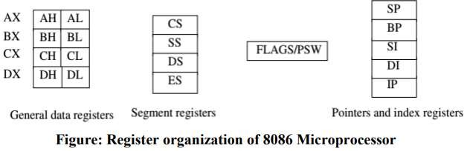
Accumulator register (AX) consists of two 8-bit registers AL(Low-order byte) and AH(High-order byte), which can be combined together and used as a 16-bit register AX. AL in this case contains and AH contains, It holds operands and results during operation
Base register (BX) consists of two 8-bit registers BL(Low-order byte) and BH(High-order byte), which can be combined together and used as a 16-bit register BX .it holds the offset address in indirect addressing mode
Count register (CX) consists of two 8-bit registers CL(Low-order byte) and CH(High-order byte), which can be combined together and used as a 16-bit register CX. It holds count for instruction.
Data register (DX) consists of two 8-bit registers DL(Low-order byte) and DH(High-order byte), which can be combined together and used as a 16-bit register DX.
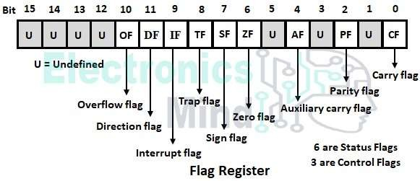

2b)Describe The Signal Capabilities Of 8086 In Minimum Mode Of Operation?
Control signals:
- ALE (Address Latch Enable) — indicates when the multiplexed address/data bus contains address (for latching the address).
- MN/MX pin is strapped low for minimum mode (the CPU drives control signals directly).
- RD (read) — active low, indicates a read operation from memory/I/O.
- WR(write) — active low, indicates write to memory/I/O.
- M/IO — high indicates memory access, low indicates I/O access.
- DT/R (Data Transmit/Receive) — selects direction of transceivers during bus cycles.
- DEN(Data Enable) — enables data transceivers to drive data on bus.
- INTA(Interrupt Acknowledge) — signals that CPU is acknowledging an interrupt vector.
- BHE(Bus High Enable) and A0 — used for byte/word selection; BHE# with A0 selects high or low bte in 16-bit data bus.
Status/Address lines:
- AD0–AD15 (time-multiplexed address/data bus) — during T1 contains address low word; later contains data.
- A16–A19/S3–S6 multiplexed — additional address bits or status signals.
Bus cycle timing — Minimum mode requires peripheral control logic to use these signals correctly (assert DEN, DT/R etc.) to perform read/write cycles.

3A)Explain the types of machine language instruction formats used in 8086?
ANY 5 Instruction formats--------------------5M
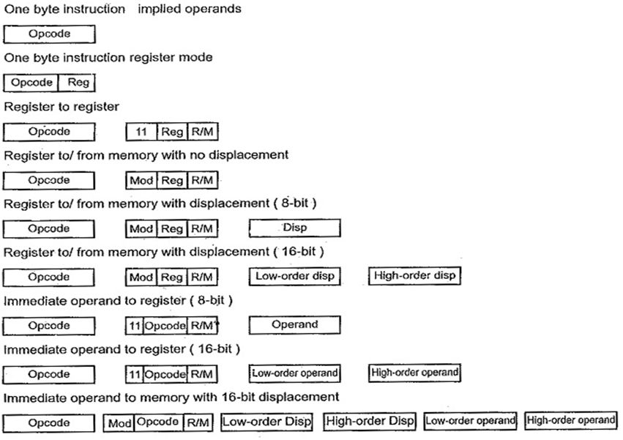
3b)Explain The Significance Of Operatorsused In 8086 Assembler Directives?
Directives (Assembler directives / pseudo-ops):
- ORG address — sets the location counter (assembly origin).
- DB (Define Byte), DW (Define Word), DD (Define Doubleword) — reserve and initialize memory constants.
- EQU — gives symbolic constants (e.g., MAX EQU 10).
- ASSUME — tells assembler which segment registers refer to which segments (ASSUME DS:DATA).
- END — marks program end; can indicate entry point.
- SEGMENT / ENDS / SECTION — group code/data into named segments.
- PROC / ENDP — define procedures (used in high-level assemblers).
These control memory layout, symbol definitions and assembler behavior.
Operators:
- Arithmetic operators during assembly time: +, -, *, /.
- DUP (duplicate) — e.g., DB 10 DUP(0) creates 10 zeros.
- OFFSET, SEG, PTR — obtain offset/segment of a label or cast pointer type for assembler.
- HIGH/LOW (in some assemblers) to extract bytes or words.
Significance: Operators & directives let programmers:
- Allocate and initialize memory.
- Set code/data organization.
- Provide symbolic constants and macros.
- Control assembler-time computations (reducing run-time cost, easy relocations).
4a)write an Assembly program to find factorial of a number using 8086?
ORG 0400H
MOV CX, [0500H]
MOV AX, 0001H
MOV DX, 0000H
LOOP_START:
MUL CX
LOOP LOOP_START
MOV [0600H], AX
MOV [0601H], DX
HLT
4b)explain the concept and structure of the stack in 8086/8088?
ack properties:
- LIFO (Last-In, First-Out) memory area. Used to store return addresses, local variables, saved registers, ISR context, and parameters.
- Located in the stack segment (SS) — stack entries are addressed using SS:SP.
- SP (Stack Pointer) contains offset of top of stack (points to last pushed word). On PUSH, SP is decremented by 2 (word push) then word is stored at SS:SP. On POP, word read from SS:SP then SP incremented by 2.
- Typical stack operations:
  - PUSH reg/mem/imm — put a word onto stack.
  - POP reg/mem — remove top word to reg/mem.
  - CALL pushes return IP and CS (for far calls) then jumps.
  - RET pops IP (and CS for far return) to resume execution.
  - INT n pushes flags, CS, IP then jumps to interrupt vector.
Stack frame convention (near procedures):
- Caller may push parameters on stack.
- CALL pushes return IP.
- Callee uses PUSH BP / MOV BP, SP to make BP point to current stack frame.
- Local variables allocated by SUB SP, <size>.
- Access parameters with positive offsets from BP ([BP+6] etc.), locals with negative offsets ([BP-2]).
5a) write a program to move a block of data from one memory location to another?
DATA
SOURCE_BLOCK DW 1, 2, 3, 4, 5, 6, 7, 8, 9, 0Ah
DEST_BLOCK DW 10 DUP(0)
COUNT EQU 10
CODE
MAIN PROC
MOV AX, @DATA
MOV DS, AX
MOV ES, AX
MOV SI, OFFSET SOURCE_BLOCK
MOV DI, OFFSET DEST_BLOCK
MOV CX, COUNT
CLD
REP MOVSW
REP MOVSW
MOV AH, 4CH
INT 21H
MAIN ENDP
END MAIN
5b) Explain the use of INT instruction in 8086 programming
The INT (Interrupt) instruction is a software mechanism used to transfer program control to an Interrupt Service Routine (ISR).
Function: It is a 2-byte instruction (e.g., INT 21H) that pushes current flags, code segment (CS), and instruction pointer (IP) onto the stack before jumping to the corresponding ISR address found in the Interrupt Vector Table (IVT).
Significance:
System Calls: It is primarily used to request services from the operating system (e.g., MS-DOS via INT 21H for I/O) or the BIOS.
Debugging: INT 3 serves as a dedicated breakpoint instruction used by debuggers.
6A) Discuss the difference between memory-mapped I/O and isolated I/O with examples?

Memory-Mapped I/O and Isolated I/O (Port-Mapped I/O)
Feature | Memory-Mapped I/O | Isolated I/O (Port-Mapped I/O)
Address Space | Shares the same address space as memory | Separate address space for I/O
Instructions Used | Uses memory instructions (MOV, ADD, SUB, etc.) | Uses special I/O instructions (IN, OUT)
Control Signals | Uses MEMR/MEMW control signals | Uses IOR/IOW control signals
Number of I/O Devices | More I/O devices can be connected (large address range) | Limited number of ports (e.g., 256 or 64K ports)
Speed | Slower due to full memory decoding | Faster because I/O decoding is simple
Operations Allowed | Arithmetic/logic operations allowed directly on I/O data | Only data transfer (no arithmetic/logic directly)
Memory Space Usage | Reduces available memory space | Does not affect memory space
Programming Complexity | Easier & flexible (same as memory access) | More restrictive (only IN and OUT)
Example | MOV A, [D000H] — D000H is an I/O device address | IN 40H or OUT 60H, AL
6b) explain the modes of Operation of 8255 PPI with block diagram?
8255 has three different operating modes –
There are two different modes of 8255. These modes are:
- Bit Set Reset (BSR) Mode
- Input/ Output Mode
Bit Set Reset (BSR) Mode
This mode is used to set or reset the bits of the Port-C only. For BSR mode always D7 will be 0. The control register is looking like this:
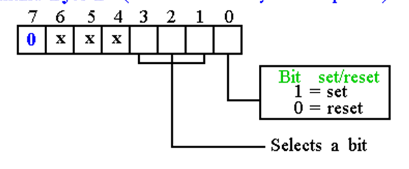
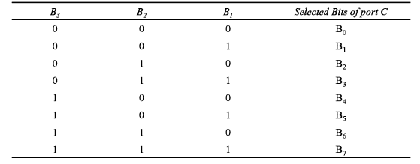
Input/ Output Mode
This mode is selected when the D7 bit of the control register is 1.
This mode has also three different modes. These modes are Mode 0 and Mode 1 and Mode 3.

- Mode 0 − In this mode, Port A and B is used as two 8-bit ports and Port C as two 4-bit ports. Each port can be programmed in either input mode or output mode where outputs are latched and inputs are not latched. Ports do not have interrupt capability.
- Mode 1 − In this mode, Port A and B is used as 8-bit I/O ports. They can be configured as either input or output ports. Each port uses three lines from port C as handshake signals. Inputs and outputs are latched.
- Mode 2 − In this mode, Port A can be configured as the bidirectional port and Port B either in Mode 0 or Mode 1. Port A uses five signals from Port C as handshake signals for data transfer. The remaining three signals from Port C can be used either as simple I/O or as handshake for port B.
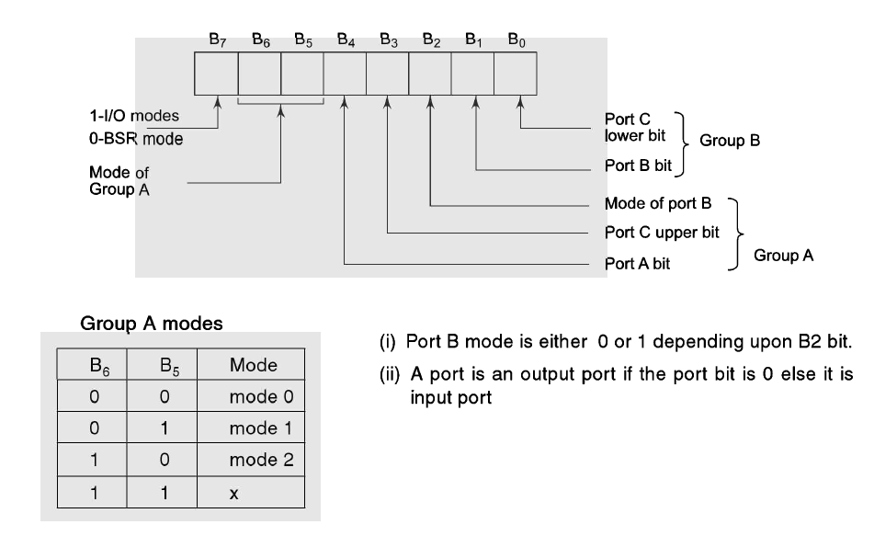
7a)write a short note on stepper motor interfacing with 8086 using driver ICs?
- A stepper motor is a device used to obtain an accurate position control of rotating shafts.
- It employs rotation of its shaft in terms of steps, rather than continuous rotation as in case of AC or DC motors.
- In dot-matrix printer one small stepper motor which is used to advance the paper to the next line position & another small stepper motor which is used to move the print head to the next character position.
- In floppy disk stepper motor is used to position the read/write head over the desired track.
- To rotate the shaft of the stepper motor, a sequence of pulses is needed to be applied to the windings of the stepper motor, in a proper sequence.
- The no. of pulses required for one complete rotation of the shaft of the stepper motor are equal to its number of internal teeth on its rotor.
- The stator teeth the rotor teeth lock with each other to fix a position of the shaft .
- With a pulse applied to the winding input, the rotor rotates by one teeth position or an angle x. The angle x may be calculated as:
  - x = 360⁰ / no. of rotor teeth
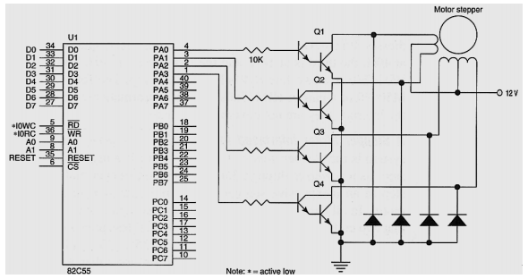

7B)Draw and explain the functional block diagram of 8259 programmable interrupt controller?
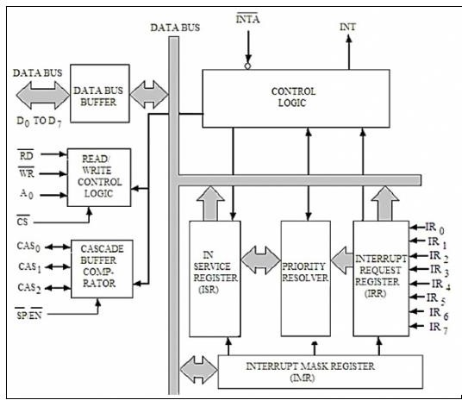
Data Bus Buffer: This block is used to communicate between 8259 and 8086 by acting as buffer. It takes the control word from 8086 and send it to the 8259. It transfers the opcode of the selected interrupts and address of ISR to the other connected microprocessor. It can send maximum 8-bit at a time.
R/W Control Logic: This block works when the value of pin CS is 0. This block is used to flow the data depending upon the inputs of RD and WR. These are active low pins for read and write.
Control Logic: It controls the functionality of each block. It has pin called INTR. This is connected to other microprocessors for taking the interrupt request. The INT pin is used to give the output. If 8259 is enabled, and also the interrupt flags of other microprocessors are high then this causes the value of the output INT pin high, and in this way this chip can responds requests made by other microprocessors.
Interrupt Request Register: It stores all interrupt level that are requesting for interrupt service.
Interrupt Service Register: It stores interrupt level that are currently being execute
Priority Resolver: It checks all three registers, and set the priority of the interrupts. Interrupt with the highest priority is set in the ISR register. It also reset the interrupt level which is already been serviced in the IRR.
Cascade Buffer: To increase number of interrupt pin, we can cascade more number of pins, by using cascade buffer. When we are going to increase the interrupt capability, CSA lines are used to control multiple interrupts.
UNIT-IV
8a) Explain The architecture of 80386DX with a neat diagram?
Architecture--------------------------------------------3M
Explanation--------------------------------------2M
Architecture of 80386
The Intel 80386 is a 32-bit microprocessor that follows a modular architecture divided into three main functional units:
1. Bus Interface Unit (BIU):
Handles communication between the processor and memory or I/O devices.
Responsible for address generation, instruction fetching, and data transfer.
Contains the instruction queue to support pipelined operation.
2. Execution Unit (EU):
Performs arithmetic, logic, and control operations.
Contains 32-bit general-purpose registers (EAX, EBX, ECX, EDX), segment registers, flags register, and the ALU.
Decodes and executes instructions received from the BIU.
3. Segmentation and Paging Unit (Memory Management Unit – MMU):
Provides segmentation (divides memory into logical segments) and paging (supports virtual memory).
Enables memory protection and multitasking in protected mode
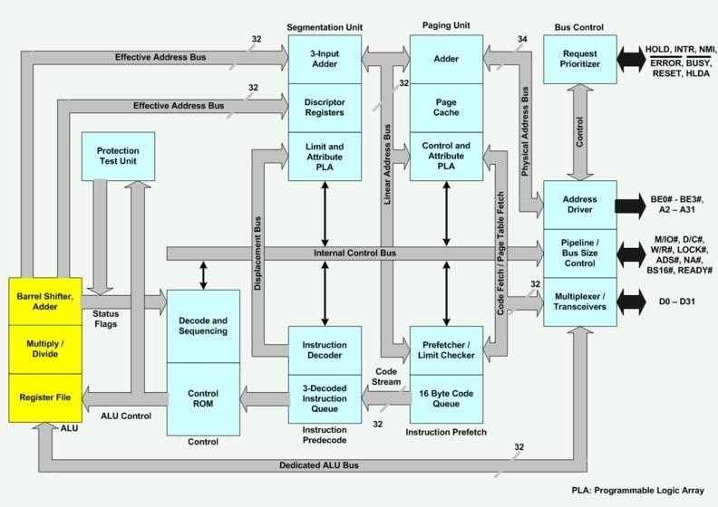

8B) Discuss The Sailent Features Of 80386?

Any five-----------------------------------------5M

Features of 80386
- As it is a 32-bit microprocessor. Thus has 32-bit ALU.
- 80386 has data bus of 32-bit.
- It holds address bus of 32 bit.
- It supports physical memory addressability of 4 GB and virtual memory addressability of 64 TB.
- 80386 supports variety of operating clock frequency, which are 16 MHz, 20 MHz, 25 MHz and 33 MHz.
- It offers 3 stage pipeline: fetch, decode and execute. As it supports simultaneous fetching, decoding and execution inside the system.
9A) Explain segmentation in 80386 with descriptor tables?
used to store the descriptor information, like attributes, limit and base addresses of segments.
• The six segment registers have corresponding six 73 bit descriptor registers. Each of them contains 32 bit base address, 32 bit base limit and 9 bit attributes. These are automatically loaded when the corresponding segments are loaded with selectors
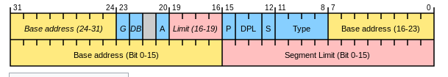

The TYPE field decides the descriptor type and hence the segment type.
•The S bit decides whether it is a system descriptor (S=0) or code/data segment descriptor ( S=1).
•The DPL field specifies the descriptor privilege level.
•The D bit specifies the code segment operation size. If D=1, the segment is a 32-bit operand segment, else, it is a 16-bit operand segment.
•The P bit (present) signifies whether the segment is present in the physical memory or not. If P=1, the segment is present in the physical memory.
•The G (granularity) bit indicates whether the segment is page addressable. The zero bit must remain zero for compatibility with future process.
•The AVL (available) field specifies whether the descriptor is for user or for operating system.
9b)Explain The Enhanced Mode Of Operation In 80386?
The enhanced mode of operation in the 80386, also known as protected mode.
It provides powerful features including 32-bit addressing, 4 GB physical memory, 64 TB virtual memory, advanced memory protection, paging, hardware multitasking, and Virtual 8086 mode.
It supports a robust environment for modern operating systems by offering strong protection, virtual memory management, privilege levels, and reliable task switching.
These enhancements make the 80386 suitable for multitasking OS like Windows and UNIX-based systems.
10)Describe the Pin configuration of 8051 micro controller?
Pin configuration----------5M
- Description of pins---------5M
- 8051 Pin configuration
- Port1 (Pin1 to Pin8): Port1 includes pin1.0 to pin1.7 and these pins can be configured as input or output pins.
- Pin 9 (RST): Reset pin is used to Reset 8051 Microcontroller by giving a positive pulse to this Pin.
- Port3 (Pin 10 to 17): The Port3 Pins are similar to port1 pins and can be used as universal Input or output pins. These pins dual-function Pins and the function of each Pin is given as:
- Pin 10 (RXD): RXD pin is a Serial Asynchronous Communication Input or Serial synchronous Communication Output.
- Pin 11 (TXD): Serial Asynchronous Communication Output or Serial Synchronous Communication clock Output.
- Pin 12 (INT0): Input of Interrupt 0
- Pin 13 (INT1): Input of Interrupt 1
- Pin 14 (T0): Input of Counter 0 clock
- Pin 15 (T1): Input of Counter 1 clock
- Pin 16 (WR): Writing Signal to write content on external RAM.
- Pin 17 (RD): Reading Signal to read contents of external RAM.
- Pin 18 and 19 (XTAL2, XTAL1): X2 and X1 pins are input output pins for the oscillator. These pins are used to connect an internal oscillator to the microcontroller.
- Pin 20 (GND): Pin 20 is a ground pin.
- Port2 (Pin 21 to Pin28): Port2 includes pin21 to pin28 which can be configured as Input Output Pins. But, this is only possible when we don’t use any external memory. If we use external memory, then these pins will work as high order address bus (A8 to A15).
- Pin 29 (PSEN): This pin is used to enable external program memory. If we use an external ROM for storing the program, then logic 0 appears on it, which indicates Micro controller to read data from the memory.
- Pin 30 (ALE): Address Latch Enable pin is an active high-output signal. If we use multiple memory chips, then this pin is used to distinguish between them. This Pin also gives program pulse input during programming of EPROM.
- Pin 31 (EA): If we have to use multiple memories then the application of logic 1 to this pin instructs the Microcontroller to read data from both memories: first internal and then external.
- Port 0 (Pin 32 to 39): Similar to the port 2 and 3 pins, these pins can be used as input output pins when we don’t use any external memory. When ALE or Pin 30 is at 1, then this port is used as data bus: when the ALE pin is at 0, then this port is used as a lower order address bus (A0 to A7)
Pin40 (VCC): This VCC pin is used for power supply.

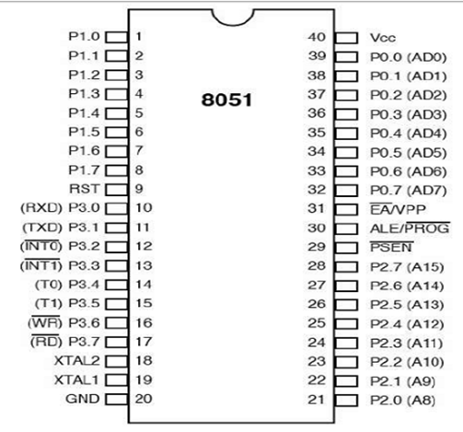

11a)Draw and explain the architecture of ARM 7 processor?
The ARM Cortex-A series processors are one branch of the ARM family which are designed for running operating systems, predominantly on mobile, internet devices.
Cortex-A stands for Application processor cores which are widely used in performance-intensive applications and this will be put to best use while used with the applications related to the Android and Linux operating systems.
They are used in a large variety of smart phones, notebooks, tablets, eBook readers, smart television sets, and digital set top boxes for digital televisions.
They are also used in some network controllers, printers, and servers
Cortex-A series offers a wide range of cores starting from Cortex-A5 to Cortex-A77, each core is designed in a way to fit into a wide range of applications. The first Cortex-A release was Cortex-A8 in 2005 and the latest one was Cortex-A77 in 2019.
The ARMv7-A architecture forms the basis of the A5, A7, A8, A9, A12, A15, A17 ,A50 and A77 processors;
The main features of Cortex-A processors are HIGH performance and brilliant power efficiency closely bundled to provide users with the best service possible.
The first Cortex-A release was Cortex-A8 in 2005 and the latest one was Cortex-A77 in 2019.

The Cortex A5 is the smallest processor of the A-range, but it can still demonstrate multicore performance.
it is compatible with A9 and A15 processors
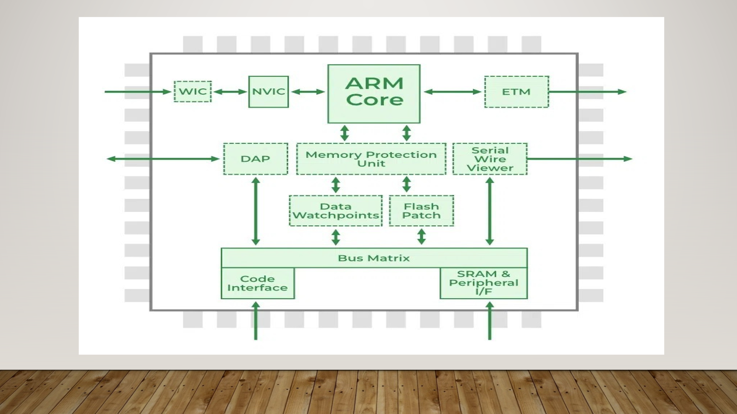

11b)write a short note on CPSR and SPSR in architecture?
Cpsr--------------------------------------------------------------3M
SPSR------------------------------------------------------------2M
CPSR and SPSR
The Current Program Status Register (CPSR) and Saved Program Status Register (SPSR) are 32-bit registers that hold the processor's status.
CPSR (Current Program Status Register)
The CPSR holds the processor's current state and is accessible in all modes. Its bits are organized into several fields:
- Condition Code Flags:
  - N (Negative): Set if the result of an arithmetic or logic operation is negative.
  - Z (Zero): Set if the result is zero.
  - C (Carry): Set if an operation produces a carry-out.
  - V (Overflow): Set if an operation produces a signed overflow.
- Control Bits:
  - Mode Bits: Determine the processor's current operating mode (e.g., User, IRQ).
  - Interrupt Disable Bits: Allow interrupts (FIQ and IRQ) to be enabled or disabled.
Thumb State Bit (T): Indicates if the processor is in ARM or Thumb state
SPSR (Saved Program Status Register)
Each privileged operating mode has its own SPSR.
- Function: The SPSR is used to preserve the state of the CPSR when an exception or interrupt occurs.
- Purpose: Before entering an exception handler, the processor automatically copies the current CPSR into the SPSR of the exception mode. This allows the processor to restore its original state by copying the SPSR back to the CPSR after the exception is handled.
Availability: The SPSR is not available in the User or System modes

